Northern Renaissance and Flemish Baroque Painters
Historical Overview
Between 1400 and 1650, Northern Europe underwent profound political, religious, and cultural transformations that shaped the development of its art. Unlike the independent city-states of Renaissance Italy, Northern Europe consisted of a diverse collection of kingdoms, duchies, and provinces, including the Burgundian Netherlands, the Holy Roman Empire, France, England, and, later, the Dutch Republic. During the fifteenth century, these regions were united primarily by the Roman Catholic Church, whose teachings, rituals, and patronage profoundly influenced artistic production. Wealth generated through trade and commerce also fostered a prosperous merchant class that increasingly commissioned paintings for private homes alongside churches and royal courts.
The Protestant Reformation, initiated by Martin Luther in 1517, transformed the political and religious landscape. The northern provinces of the Netherlands eventually became the Dutch Republic, where Calvinism predominated and artists increasingly worked for educated private collectors. In contrast, the Southern Netherlands remained under Spanish Habsburg rule and loyal to Roman Catholicism during the Counter-Reformation, continuing to commission religious works and portraits celebrating church and royal authority.
Despite these divisions, Northern European artists shared a commitment to careful observation of nature, meticulous craftsmanship, and the convincing depiction of the visible world. The four artists presented here illustrate the evolution of Northern European painting from the symbolic spirituality of the late Middle Ages through Northern Mannerism to the grandeur of the Flemish Baroque.

A Changing World Reflected in Art
The following four paintings demonstrate how Northern European artists responded to changing political, religious, and cultural conditions while continually advancing realism, symbolism, and artistic innovation. As you view each work, consider how its patronage, subject matter, style, and technique reflect the historical moment in which it was created.

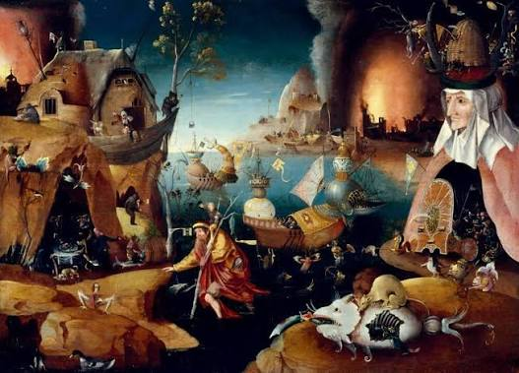
Hieronymus Bosch
Saint Christopher Carrying the Christ Child Through a Sinful World (c. 1490–1500)
Hieronymus Bosch transformed the familiar legend of Saint Christopher into a symbolic moral landscape. Instead of simply illustrating the saint carrying the Christ Child across a river, Bosch filled the surrounding world with images of temptation, violence, and human folly. The painting reflects the Late Medieval Catholic worldview while encouraging viewers to contemplate the spiritual journey toward salvation. His careful observation of nature combined with symbolic meaning helped establish the foundations of Northern Realism.
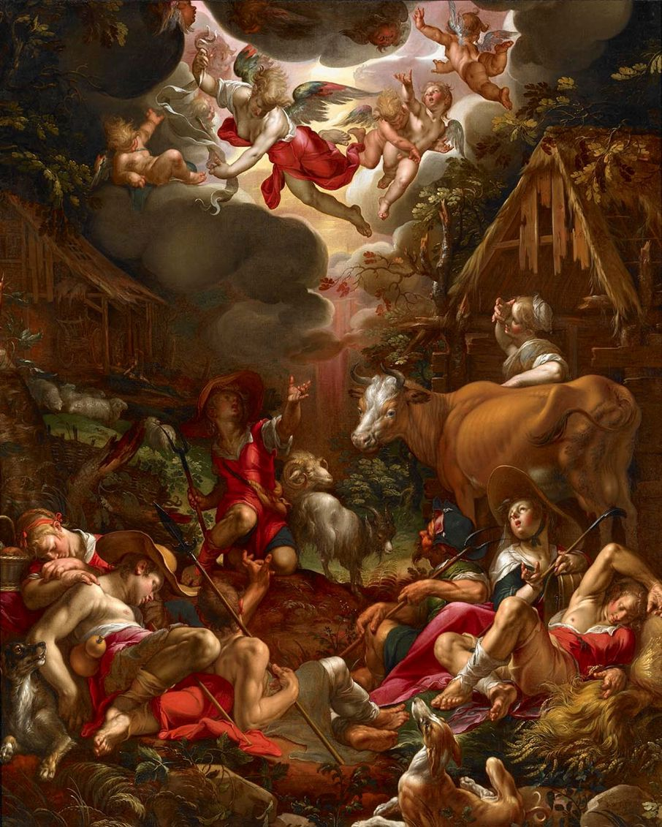
Joachim Wtewael
Annunciation to the Shepherds (c. 1595–1599)
Joachim Wtewael exemplified Northern Mannerism through elongated figures, brilliant color, and dramatic movement. Although the subject is biblical, the painting was intended for educated private collectors who appreciated artistic invention and technical virtuosity. Wtewael transformed a familiar religious narrative into a sophisticated display of composition, anatomy, and theatrical design.

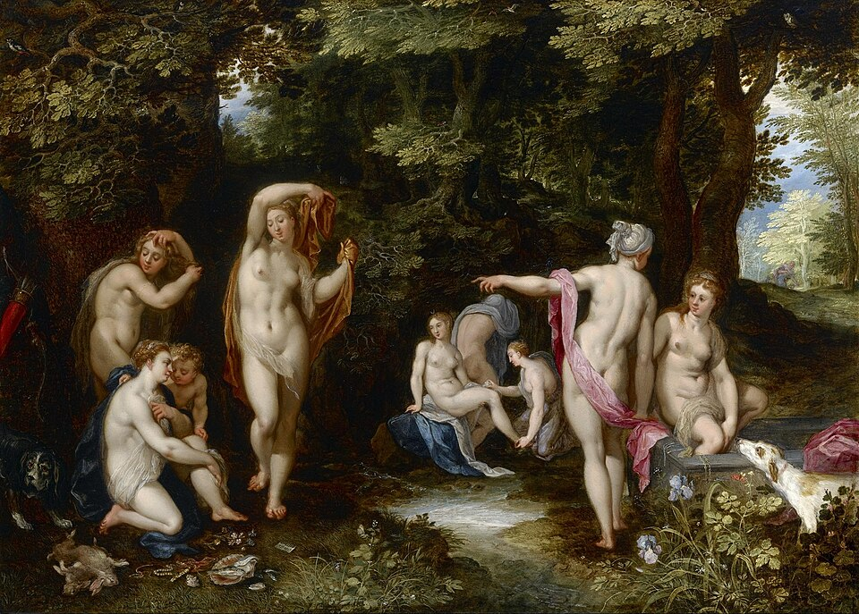

Jan Brueghel the Elder
Diana and Actaeon (c. 1605–1610)
Drawing upon Ovid's Metamorphoses, Jan Brueghel the Elder combined classical mythology with extraordinary observation of the natural world. The meticulously rendered trees, animals, and landscape are as important as the mythological figures themselves, reflecting the Flemish Baroque appreciation for nature. Through his delicate brushwork, Brueghel elevated landscape from a background setting to a principal subject in its own right.
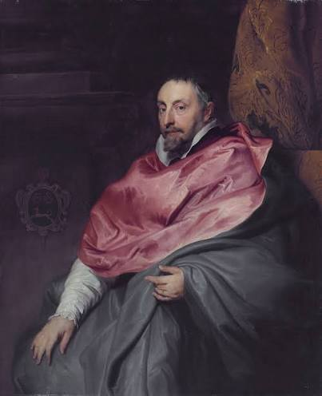
Sir Anthony van Dyck
Portrait of Bishop Antoine Triest (c. 1627)
Sir Anthony van Dyck portrayed Bishop Antoine Triest with elegance, dignity, and psychological depth. Painted during the Counter-Reformation, the portrait reinforces the authority of the Catholic Church while presenting the bishop as an individual of intelligence and humanity. Van Dyck's naturalistic approach and refined portrait style influenced generations of European portrait painters.
Concluding Reflection
These four paintings consider how Northern European art evolved over nearly two centuries. Bosch communicates moral lessons through medieval symbolism, Wtewael transforms biblical narratives into sophisticated Mannerist compositions, Brueghel elevates nature through careful observation, and Van Dyck culminates this progression with psychologically compelling portraiture. Together, these artists demonstrate how political change, religious reform, and human curiosity shaped Northern European painting from the fifteenth through the seventeenth century.

Image Citations
Bosch: Hieronymus Bosch, Saint Christopher Carrying the Christ Child Through a Sinful World, c. 1490–1500. Museum Boijmans Van Beuningen, Rotterdam.
Wtewael: Joachim Wtewael, Annunciation to the Shepherds, c. 1595–1599. National Gallery of Art, Washington, D.C.
Brueghel: Jan Brueghel the Elder, Diana and Actaeon, c. 1605–1610. Public domain reproduction via Google Arts & Culture.
Van Dyck: Sir Anthony van Dyck, Portrait of Bishop Antoine Triest, c. 1627. Koninklijk Museum voor Schone Kunsten Antwerpen.

